LAB PROGRAMS 4 & 5
NAME: KAVIPRIYA P
REG NO: 192424027
4. Write a Pandas program to create a line plot of the historical stock
prices of Alphabet Inc. between two specific dates.
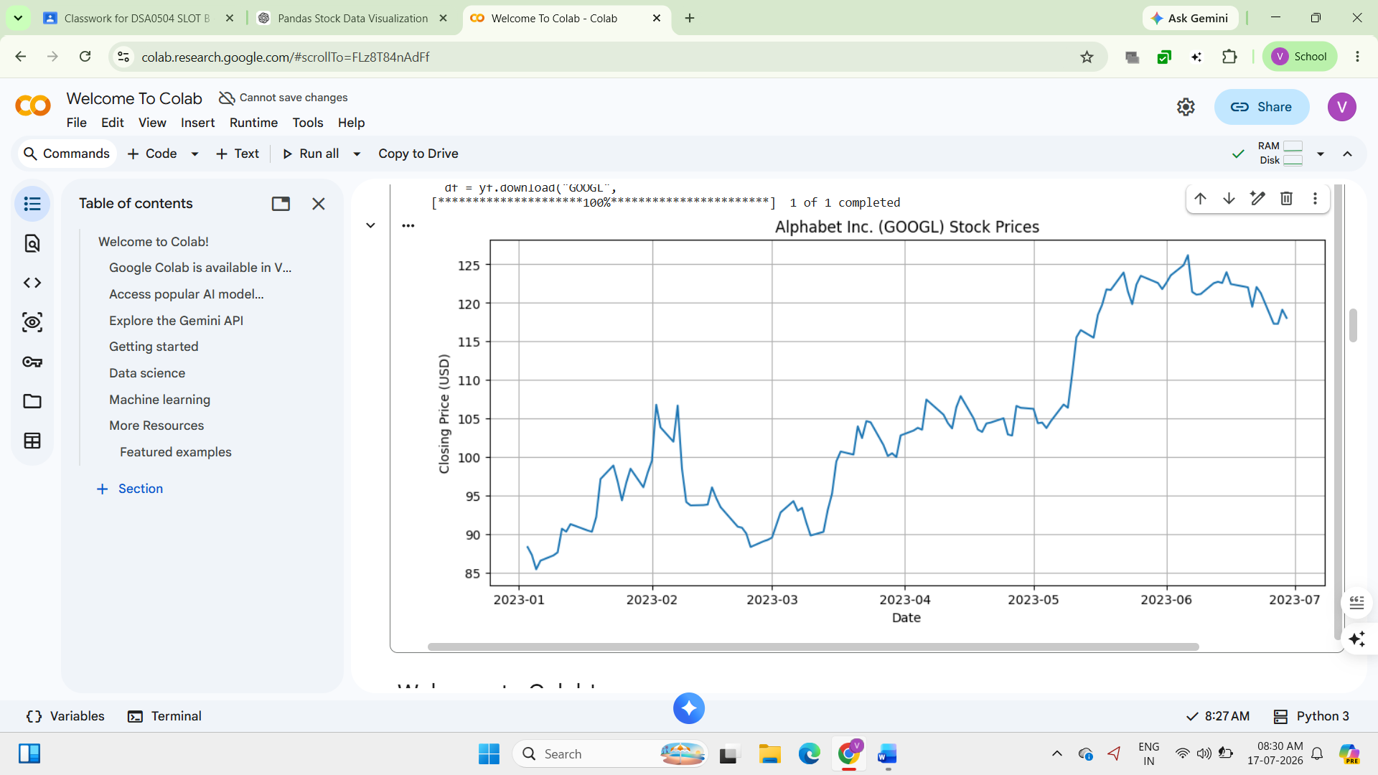
5.Write a Pandas program to create a bar plot of the trading volume of
Alphabet Inc. stock between two specific dates.
# Install yfinance
!pip install yfinance

import yfinance as yf
import matplotlib.pyplot as plt

# Download Alphabet stock data
df = yf.download("GOOGL",
start="2023-01-01",
end="2023-06-30")

# Bar Plot of Trading Volume
plt.figure(figsize=(12,5))
plt.bar(df.index, df['Volume'])

plt.title("Alphabet Inc. (GOOGL) Trading Volume")
plt.xlabel("Date")
plt.ylabel("Volume")
plt.xticks(rotation=45)
plt.tight_layout()
plt.show()

